Order Of Service

Singing: Psalm 66—CW page 90

Reading: Psalm 48

Opening Hymn: TLH 55

Reading: Galatians 3:1-18

Request Hymn: CW Supplement 748

Reading: Mark 9:9-13

Sermon Hymn: TLH 339

Sermon Text: Luke 18:24-30

Question & Answer

Prayer

The Apostles’ Creed, TLH page 12

Holy Communion

The Lord's Prayer

The Blessing

Closing Hymn: TLH 61

************

Bible Study: Lambs: Border Collie
Sheep: Deuteronomy 1:9-18
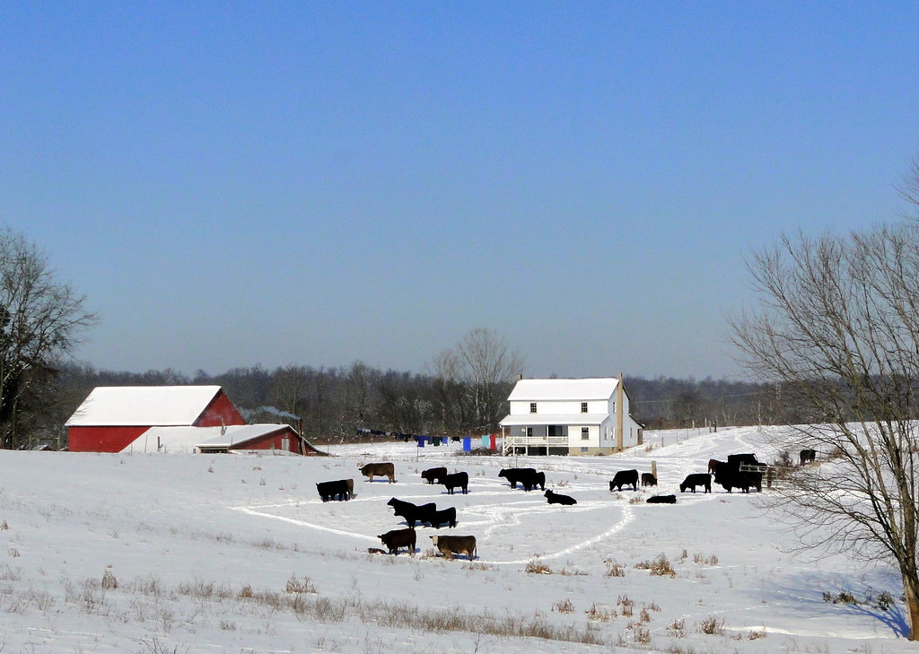

Winter Farm In Wisconsin

Water

Of
Life

11 December 2022

W A T E R O F L I F E

Independent Christian Church—Conservative Lutheran Doctrine

Worship Service: 9:30 a.m.

Larry Cooper, Pastor E-Mail address:
111 N. Ridge Road lcooper@wateroflife.cc
Coon Valley, WI 54623 Web Site:
www.wateroflife.cc

* * * * * * * * * * * * * * * * * * * * * * * * * * *

Sermon Text: Luke 18:24-30

Question & Answer

* * * * * * * * * * * * * * * * * * * * * * * * * * *

24 And when Jesus saw that he was very sorrowful, he said, How hardly shall they that have riches enter into the kingdom of God!
25 For it is easier for a camel to go through a needle's eye, than for a rich man to enter into the kingdom of God.
26 And they that heard it said, Who then can be saved?
27 And he said, The things which are impossible with men are possible with God.
28 Then Peter said, Lo, we have left all, and followed thee.
29 And he said unto them, Verily I say unto you, There is no man that hath left house, or parents, or brethren, or wife, or children, for the kingdom of God's sake,
30 Who shall not receive manifold more in this present time, and in the world to come life everlasting.

